setwd("D:/998.Python/Data-Analysis-Portfolio/project_06_total_happiness_R")

지금 생각 중인건
랜덤포레스트 등이랑
BIC 등 실현.

지금 데이터 다시 둘러보면서 해야 할 것같아
결측, 미싱밸류, NA 등. 그다음 다시 해야돼
BIC랑 랜덤포레스트, 부스팅인가 마지막에 한거 이 정도 해서 주면 될 듯.
기존에 했던 그 내용에 그냥 모델만 바꿔서 주는 게 더 편할 듯.

데이터 구조(총 10개 열) : year(2015~2023) 수기입력, country, region, happiness_score, gdp_per_capita, social_support, healthy_life_expectancy, freedom_to_make_life_choices, generosity, perceptions_of_corruption

이 각각의 6개 변수로 happiness score을 회귀분석 중인데 연도별로 베타1이 어떻게 변하는지 이런거 보고 그래프도 그리고 싶어.

Time regression (regression)

### initial setting ###

setwd("D:/998.Python/Data-Analysis-Portfolio/project_06_total_happiness_R")
# data processing
df <- read.csv("data/full_data.csv")
df$year <- as.integer(df$year)
df$country <- as.factor(df$country)
df$region <- as.factor(df$region)
key_vars <- c(
"happiness_score",
"gdp_per_capita",
"social_support",
"healthy_life_expectancy",
"freedom_to_make_life_choices",
"generosity",
"perceptions_of_corruption"
)

# drop out the missing values
df_clean <- na.omit(df)
df_clean$perceptions_of_corruption[df_clean$perceptions_of_corruption == "N/A"] <- NA
df_clean <- df_clean[complete.cases(df_clean), ]
df_clean$perceptions_of_corruption <- as.numeric(df_clean$perceptions_of_corruption)

# 2015~2022: train , 2023 : test
train_data <- df_clean[df_clean$year <= 2022, ]
test_data <- df_clean[df_clean$year == 2023, ]

str(df_clean)

# delete duplicate
library(dplyr)
df_clean <- df_clean %>% distinct()

★★★★★ There are some duplicates in our dataset ★★★★★

############### Diagnosis ######################
List
1. Outliers
2. Leverage
3. Influential Point
4. QQ plot
5. Shapiro-wilk
6. Cook’s Distance

#1~3 I analyzed the 1~3(Outliers, Leverage, Influential Point).
library(dplyr)
library(broom)
library(ggplot2)

all_diagnosis_df <- list()
for(year in unique(df_clean$year)) {
df_year <- df_clean %>% filter(year == !!year)

# linear regression (lm)
model <- lm(happiness_score ~ gdp_per_capita + social_support +
healthy_life_expectancy + freedom_to_make_life_choices +
generosity + perceptions_of_corruption,
data = df_year)

# dependent (k), observation (n)
k <- length(coef(model)) - 1 # 절편 제외
n <- nrow(df_year)

# calculate threshold
leverage_threshold <- 2 * (k + 1) / n
cooks_d_threshold <- 4 / n
outlier_threshold <- 3 # 표준화 잔차의 절대값이 3 초과

# calculate
diag_values <- data.frame(
country = df_year$country,
year = year,
std_residual = rstandard(model),
hat_value = hatvalues(model),
cooks_d = cooks.distance(model)
)

# Is it higher than threshold?
diag_values <- diag_values %>%
mutate(
is_outlier = abs(std_residual) > outlier_threshold,
is_leverage = hat_value > leverage_threshold,
is_influential = cooks_d > cooks_d_threshold,
# Check whether it belongs to at least one of them
is_problem = is_outlier | is_leverage | is_influential
)

all_diagnosis_df[[as.character(year)]] <- diag_values
}

# combine all of data
combined_diagnosis_df <- bind_rows(all_diagnosis_df)

# filter
problematic_obs <- combined_diagnosis_df %>%
filter(is_problem == TRUE) %>%
select(year, country, std_residual, hat_value, cooks_d, is_outlier, is_leverage, is_influential) %>%
arrange(year, desc(cooks_d))

## summarize problematic values
print(problematic_obs)

year | country | std_residual | hat_value | cooks_d | is_outlier | is_leverage | is_influential
2015 | Rwanda | -2.76365936 | 0.14904759 | 1.911132e-01 | FALSE | TRUE | TRUE
2015 | Syria | -2.57161151 | 0.10703475 | 1.132408e-01 | FALSE | TRUE | TRUE
2015 | Pakistan | 2.56565317 | 0.07256301 | 7.357474e-02 | FALSE | FALSE | TRUE
2015 | Central African Republic | 1.71703406 | 0.14396812 | 7.083309e-02 | FALSE | TRUE | TRUE
2015 | Botswana | -1.54528786 | 0.15075853 | 6.055799e-02 | FALSE | TRUE | TRUE
2015 | Cambodia | -1.91681637 | 0.07747792 | 4.408229e-02 | FALSE | FALSE | TRUE
2015 | Hong Kong S.A.R. of  China | -2.41106137 | 0.04578958 | 3.985116e-02 | FALSE | FALSE | TRUE
2015 | Gabon | -2.07053903 | 0.04630848 | 2.973866e-02 | FALSE | FALSE | TRUE
2015 | Mexico | 2.75703526 | 0.02350341 | 2.613646e-02 | FALSE | FALSE | TRUE
2015 | Qatar | -0.75402583 | 0.11203030 | 1.024735e-02 | FALSE | TRUE | FALSE
2015 | Myanmar | -0.59521760 | 0.15321175 | 9.157370e-03 | FALSE | TRUE | FALSE
2015 | Georgia | -0.61861541 | 0.12088846 | 7.517688e-03 | FALSE | TRUE | FALSE
2015 | Swaziland | 0.58058046 | 0.09208687 | 4.884051e-03 | FALSE | TRUE | FALSE
2015 | Somaliland region | 0.26045464 | 0.10172450 | 1.097444e-03 | FALSE | TRUE | FALSE
2016 | Rwanda | -2.91626936 | 0.13994380 | 1.976897e-01 | FALSE | TRUE | TRUE
2016 | Somalia | 2.91330712 | 0.10144311 | 1.368836e-01 | FALSE | TRUE | TRUE
2016 | Syria | -2.17992248 | 0.13489574 | 1.058556e-01 | FALSE | TRUE | TRUE
2016 | Botswana | -2.64734774 | 0.04578032 | 4.803462e-02 | FALSE | FALSE | TRUE
2016 | Hong Kong S.A.R. of China | -2.56307602 | 0.04612233 | 4.537780e-02 | FALSE | FALSE | TRUE
2016 | Pakistan | 2.19461289 | 0.05290499 | 3.843447e-02 | FALSE | FALSE | TRUE
2016 | Sri Lanka | -2.52418247 | 0.03890395 | 3.684431e-02 | FALSE | FALSE | TRUE
2016 | Cambodia | -1.89470606 | 0.06078644 | 3.319159e-02 | FALSE | FALSE | TRUE
2016 | Nigeria | 1.53763283 | 0.08636003 | 3.192603e-02 | FALSE | FALSE | TRUE
2016 | Qatar | -1.17828430 | 0.11592837 | 2.600785e-02 | FALSE | TRUE | TRUE
2016 | Myanmar | -0.88163129 | 0.14350584 | 1.860463e-02 | FALSE | TRUE | FALSE
2016 | Georgia | -0.97774865 | 0.11193197 | 1.721331e-02 | FALSE | TRUE | FALSE
2016 | Somaliland Region | 0.51287198 | 0.09931802 | 4.143587e-03 | FALSE | TRUE | FALSE
2016 | Angola | 0.14210052 | 0.13464226 | 4.488270e-04 | FALSE | TRUE | FALSE

##### create report #####
# install.packages("ggplot2")
library(ggplot2)

# Cook's D를 기준으로 상위 5~10개 국가만 시각화하거나, is_influential=TRUE인 국가만 사용
plot_data <- problematic_obs %>%
filter(is_influential == TRUE) %>%
# Cook's D를 기준으로 상위 10개 국가만 선택하여 그래프를 깔끔하게 유지 (선택 사항)
group_by(country) %>%
mutate(total_cooks_d = sum(cooks_d)) %>%
ungroup() %>%
top_n(10, total_cooks_d)

ggplot(plot_data, aes(x = year, y = cooks_d, color = country)) +
geom_line(linewidth = 1, alpha = 0.6) +
geom_point(size = 3) +

# Cook's D가 높은 국가 이름을 점 옆에 표시
geom_text(aes(label = ifelse(cooks_d > 0.1, as.character(country), "")),
vjust = -1, hjust = 0.5, size = 3, check_overlap = TRUE) +

facet_wrap(~ country) + # 국가별로 그래프 분할
labs(
title = "Cook's Distance of Influential Countries Over Time",
subtitle = "Identifying persistent exceptional cases influencing model coefficients",
x = "Year",
y = "Cook's Distance (Model Influence)",
color = "Country"
) +
theme_minimal(base_size = 14) +
theme(legend.position = "none",
plot.title = element_text(face = "bold"))

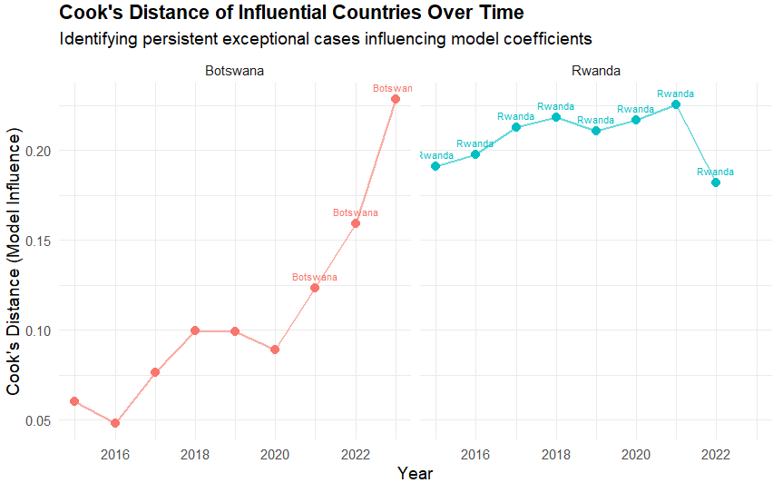

# Dive into Botswana and Rwanda.
library(dplyr)
library(ggplot2)

# filtering 2 countries
target_countries <- c("Botswana", "Rwanda")
target_data <- combined_diagnosis_df %>%
filter(country %in% target_countries)

# change the form of data (to use in ggplot)
plot_long <- target_data %>%
select(year, country, std_residual, hat_value, cooks_d) %>%
tidyr::pivot_longer(
cols = c(std_residual, hat_value, cooks_d),
names_to = "Metric",
values_to = "Value"
)

# visulization
ggplot(plot_long, aes(x = year, y = Value, color = Metric, group = Metric)) +
geom_line(linewidth = 1) +
geom_point(size = 2) +
facet_wrap(~ country, scales = "free_y", ncol = 1) +
labs(
title = "Diagnostic Metrics for Botswana and Rwanda Over Time",
subtitle = "Identifying the source of high Cook's Distance (Residual vs. Leverage)",
x = "Year",
y = "Metric Value"
) +
theme_minimal(base_size = 14)

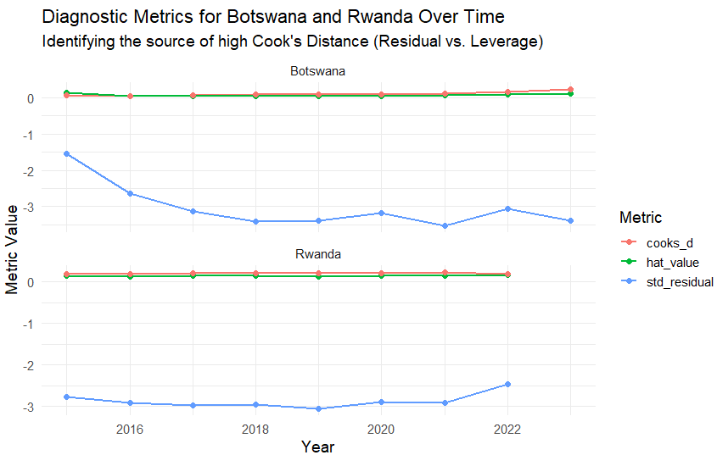

############ analyze Rwanda ###############

library(dplyr)
library(ggplot2)
library(tidyr)

# Define Independent Variables (X-Variables)
predictors <- c("gdp_per_capita", "social_support", "healthy_life_expectancy",
"freedom_to_make_life_choices", "generosity", "perceptions_of_corruption")

# 1. Data Standardization (Z-Score Calculation)
# Z-Score: (Value - Mean) / Standard Deviation. 0 represents the mean.
df_standardized <- df_clean %>%
# Standardize across all observations for comparative clarity
mutate(across(all_of(predictors), scale)) %>%
ungroup()

# 2. Data Preparation: Filter Rwanda and rename groups
comparison_data_std <- df_standardized %>%
mutate(Group = ifelse(country == "Rwanda", "Rwanda", "All Other Countries")) %>%
select(Group, country, year, all_of(predictors))

plot_long_std <- comparison_data_std %>%
tidyr::pivot_longer(
cols = all_of(predictors),
names_to = "Variable",
values_to = "Z_Score"
)

# 3. Visualization: Box Plot with Rwanda's Z-Scores highlighted
ggplot(plot_long_std, aes(x = Variable, y = Z_Score)) +

# 1. Box Plot (Global Distribution Z-Scores)
geom_boxplot(aes(fill = Variable), outlier.shape = NA, alpha = 0.4) +

# 2. Rwanda's Z-Scores (Points) - Plotting all years
geom_point(data = filter(plot_long_std, Group == "Rwanda"),
aes(color = Group),
size = 4,
alpha = 1,
position = position_jitter(width = 0.15)) +

# 3. Y=0 line (Global Average)
geom_hline(yintercept = 0, linetype = "dashed", color = "black", linewidth = 1) +

# 4. Labels: Label Rwanda's points with the year
geom_text(data = filter(plot_long_std, Group == "Rwanda"),
aes(label = year, color = Group),
vjust = -1.5, size = 3.5, position = position_jitter(width = 0.15)) +

# 5. Facet Wrap
facet_wrap(~ Variable, scales = "free_y", ncol = 3) +

labs(
title = "Rwanda's X-Variable Position: Z-Score Comparison against Global Average",
subtitle = "Z-Score: 0 = Global Mean, ±1 = 1 Standard Deviation. Confirming low Leverage.",
x = "",
y = "Z-Score (Standard Deviation from Mean)"
) +
theme_minimal(base_size = 14) +
theme(
axis.text.x = element_blank(),
axis.ticks.x = element_blank(),
plot.title = element_text(face = "bold"),
legend.position = "none"
)

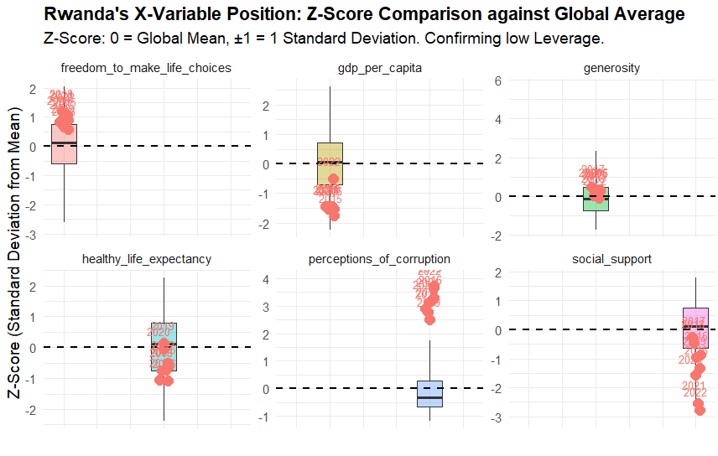

### Analyze Botswana ###################
library(dplyr)
library(ggplot2)
library(tidyr)

# Define Independent Variables (X-Variables)
predictors <- c("gdp_per_capita", "social_support", "healthy_life_expectancy",
"freedom_to_make_life_choices", "generosity", "perceptions_of_corruption")

# 1. Data Standardization (Z-Score Calculation)
# Z-Score: (Value - Mean) / Standard Deviation. 0 represents the mean.
df_standardized <- df_clean %>%
mutate(across(all_of(predictors), scale)) %>%
ungroup()

# 2. Data Preparation: Filter Botswana data
comparison_data_std <- df_standardized %>%
mutate(Group = ifelse(country == "Botswana", "Botswana", "All Other Countries")) %>%
select(Group, country, year, all_of(predictors))

plot_long_std <- comparison_data_std %>%
tidyr::pivot_longer(
cols = all_of(predictors),
names_to = "Variable",
values_to = "Z_Score"
)

# 3. Visualization: Box Plot with Botswana's Z-Scores highlighted
ggplot(plot_long_std, aes(x = Variable, y = Z_Score)) +

# 1. Box Plot (Global Distribution Z-Scores)
geom_boxplot(aes(fill = Variable), outlier.shape = NA, alpha = 0.4) +

# 2. Botswana's Z-Scores (Points) - Plotting all years
geom_point(data = filter(plot_long_std, Group == "Botswana"),
aes(color = Group),
size = 4,
alpha = 1,
position = position_jitter(width = 0.15)) +

# 3. Y=0 line (Global Average)
geom_hline(yintercept = 0, linetype = "dashed", color = "black", linewidth = 1) +

# 4. Labels: Label Botswana's points with the year
geom_text(data = filter(plot_long_std, Group == "Botswana"),
aes(label = year, color = Group),
vjust = -1.5, size = 3.5, position = position_jitter(width = 0.15)) +

# 5. Facet Wrap
facet_wrap(~ Variable, scales = "free_y", ncol = 3) +

labs(
title = "Botswana's X Variable Position: Z-Score Comparison Against Global Average",
subtitle = "Identifying variables causing high Leverage (X-extremity)",
x = "",
y = "Z-Score (Standard Deviation from Mean)"
) +
theme_minimal(base_size = 14) +
theme(
axis.text.x = element_blank(),
axis.ticks.x = element_blank(),
plot.title = element_text(face = "bold"),
legend.position = "none"
)

